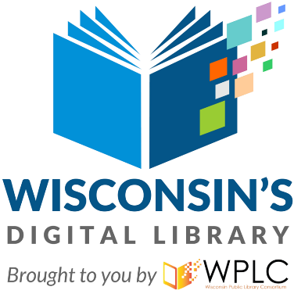
FOR IMMEDIATE RELEASE

Wisconsin‘s Digital Library Sees Nearly 7 Million Ebook and Audiobook Checkouts in 2020
#4 public library system worldwide in total digital circulation

Wisconsin – February 8, 2021 – In 2020, Wisconsin’s Digital Library, provided by a collaboration of all 16 of the state’s public library systems, broke records by lending nearly 7 million digital books and audiobooks. For each of the last six years, Wisconsin’s Digital Library has seen steady usage growth between 10% and 20%, highlighting the value of public library lending of ebooks and digital audiobooks. This year, with access to physical library buildings limited throughout the state and many school districts teaching students virtually due to the pandemic, the digital library’s importance to the residents of Wisconsin was even more clear. New users of the library jumped 30% and checkouts increased nearly 20% over 2019.
Of the more than 100,000 titles in the collection, the digital audiobook of Harry Potter and the Sorcerer's Stone by J.K. Rowling was the one that readers borrowed the most in 2020.
The top 5 ebook titles borrowed through Wisconsin’s Digital Library in 2020:
- The Whistler by John Grisham
- Where the Crawdads Sing by Delia Owens
- Becoming by Michelle Obama
- So You Want to Talk about Race by Ijeoma Oluo
- Big Little Lies by Liane Moriarty
The top 5 digital audiobook titles borrowed through Wisconsin’s Digital Library in 2020:
- Harry Potter and the Sorcerer's Stone by J. K. Rowling
- The Last Widow by Karin Slaughter
- Little Women by Louisa May Alcott
- Talking to Strangers by Malcolm Gladwell
- Finding Mrs. Ford by Deborah Goodrich Royce
Readers in Wisconsin just need a valid library card to access digital books from Wisconsin’s Digital Library, powered by OverDrive, using any major device, mobile or desktop. Visit https://wplc.overdrive.com/, download the Libby app, or call your local library to get started borrowing ebooks and audiobooks anytime, anywhere, for free.
Contact:
Melody Clark
WPLC c/o WiLS
Community Liaison / Service Specialist
mclark@wils.org

###

